**IBM CLOUD SERVICES**

|  |  |
| --- | --- |
| **DATE** | 14 NOVEMBER 2022 |
| **TEAM ID** | PNT2022TMID48639 |
| **PROJECT TITLE** | IoT Based smart crop Protection System for agriculture |

**IBM WATSON AND IOT PLATFORM:**

**STEP1:**

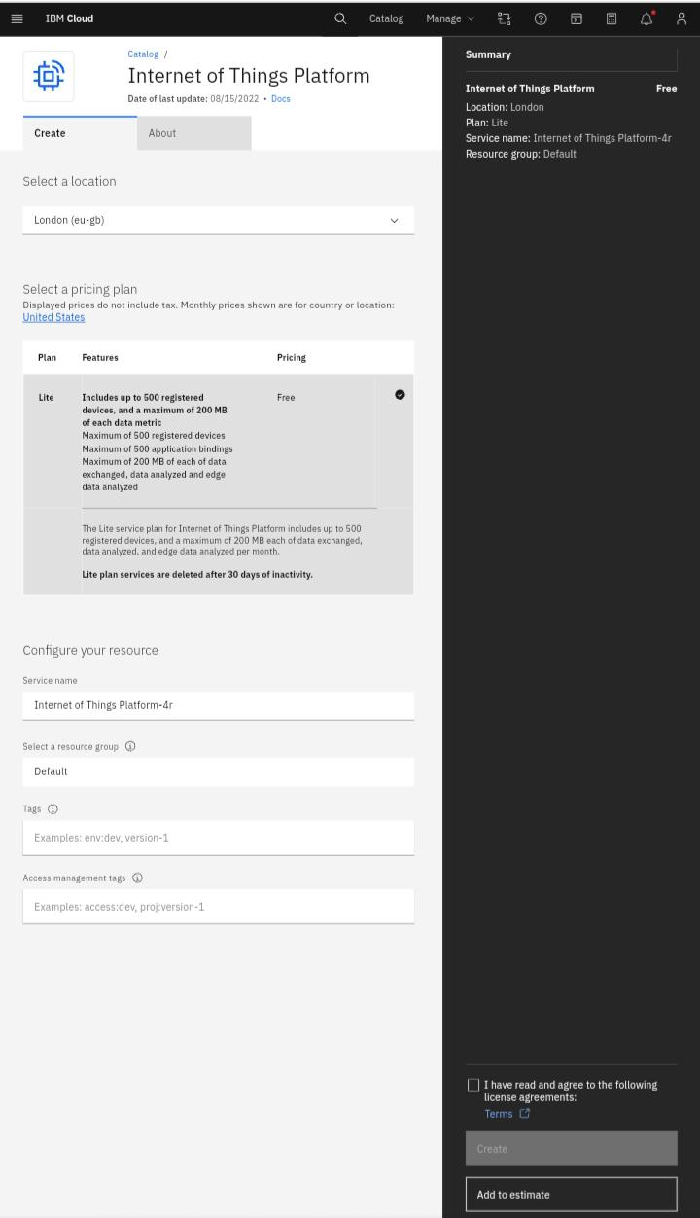

**STEP 2:** 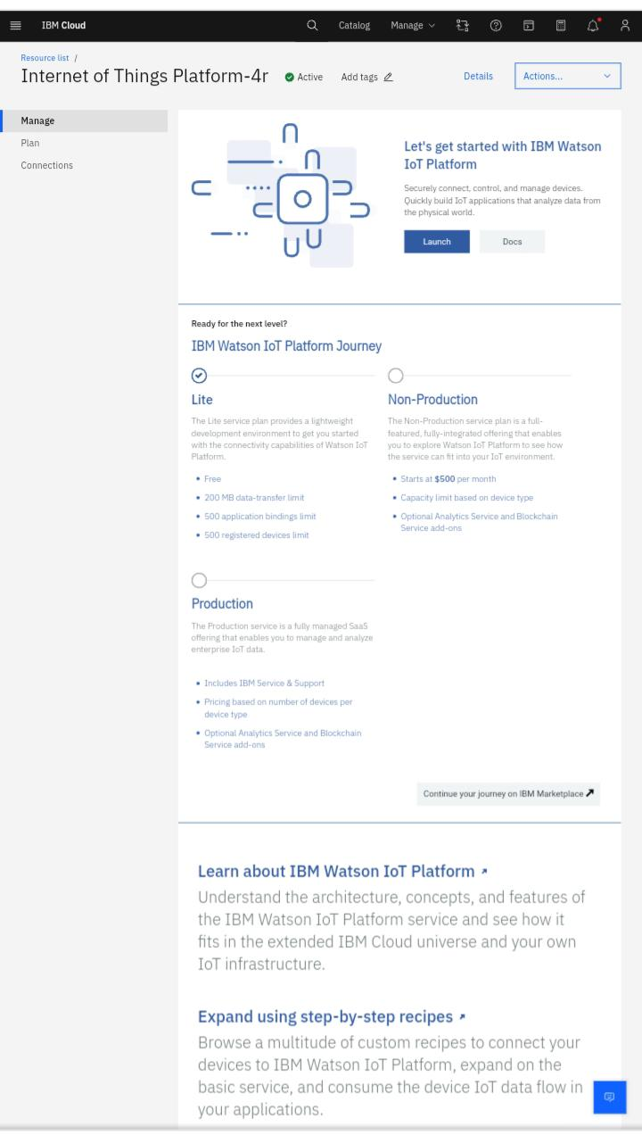

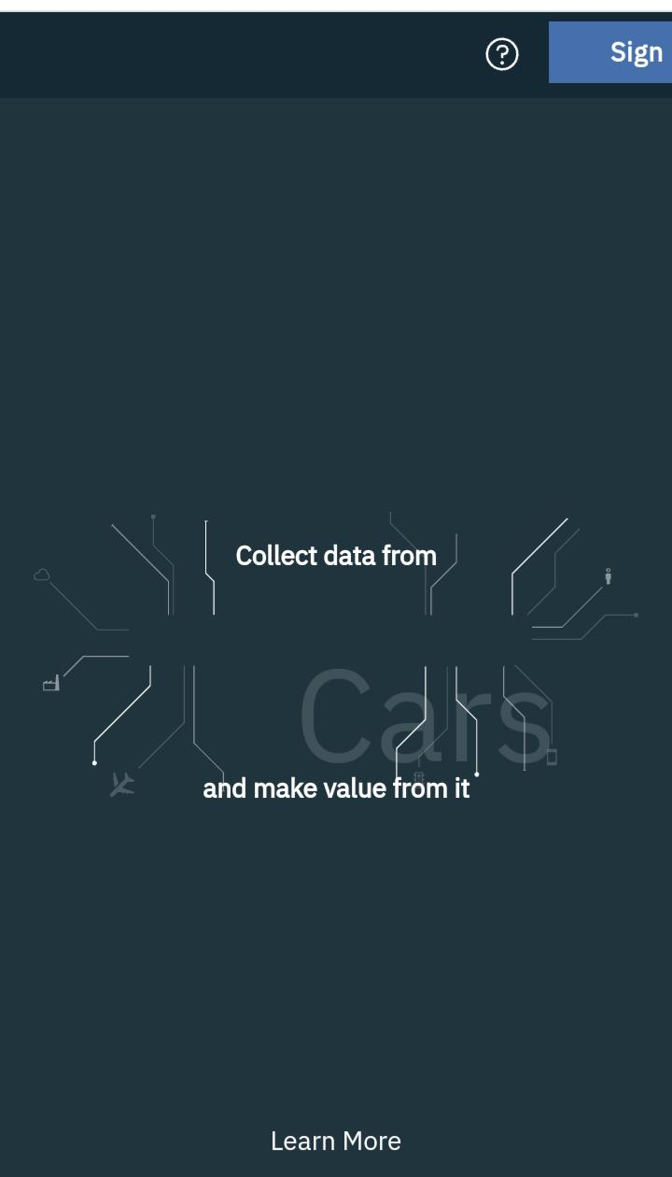**STEP 3:**

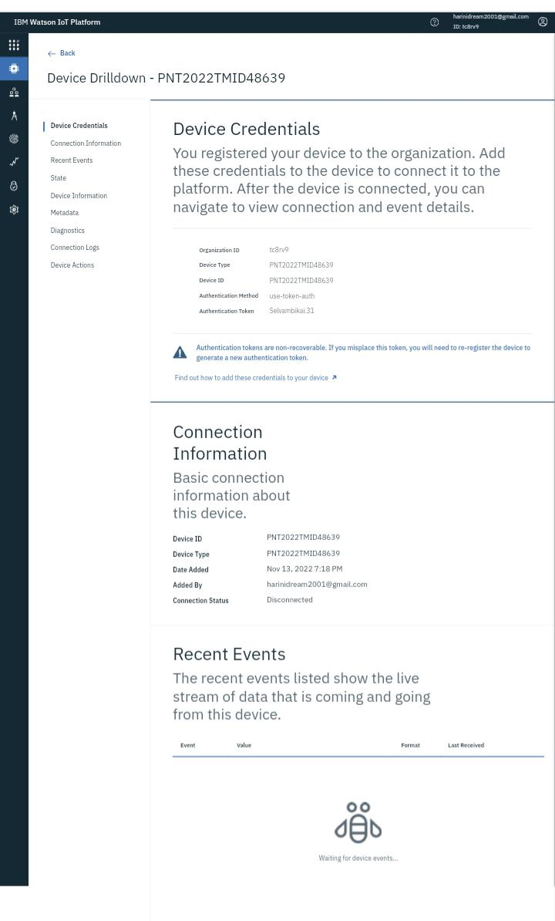**STEP 4:**

**STEP 5:** 